**Banking system resilience during economic crises**

During hard times, the U.S. banking system has played a crucial role in stabilizing the economy, supporting businesses and individuals, and implementing policies to manage crises. Here is an overview of how the banking system was managed, functioned, and contributed to the country during various economic crises, along with the key policies implemented during those times:

During World War II, the U.S. banking system played a crucial role in supporting the war effort, managing economic challenges, and ensuring financial stability. Here's how the banking system managed during that time:

1. **War Financing and Government Support**

War Bonds: Banks facilitated the sale of war bonds to finance the war effort. These bonds were sold to individuals and organizations to raise funds for military expenses.

Government Loans: Banks provided loans to the government to support wartime production and infrastructure development. The government relied on banks to finance its operations and ensure adequate liquidity.

1. **Financial Stability Measures**

Regulatory Cooperation: Regulatory agencies worked closely with banks to ensure financial stability during wartime. Banks implemented strict controls and measures to prevent financial instability and maintain public confidence.

Liquidity Support: The Federal Reserve provided liquidity support to banks to ensure the smooth functioning of financial markets and banking operations

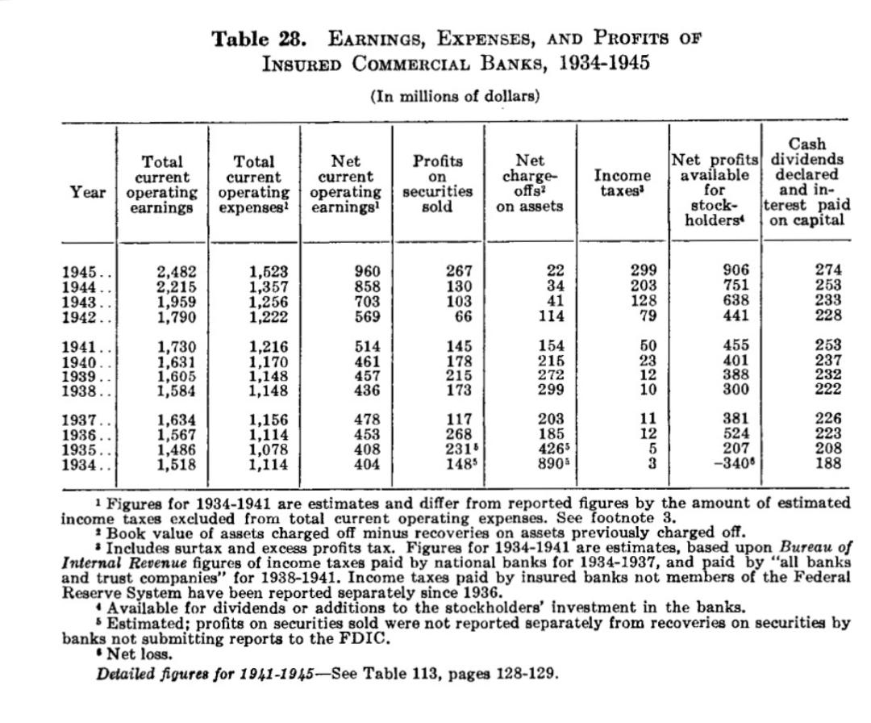

1. **Rationing and Economic Controls**

Rationing Programs: Banks assisted in implementing rationing programs to manage shortages of goods and resources during wartime. They played a role in distributing ration coupons and enforcing rationing regulations.

Price Controls: Banks complied with government-imposed price controls and regulations to manage inflation and stabilize the economy during wartime.

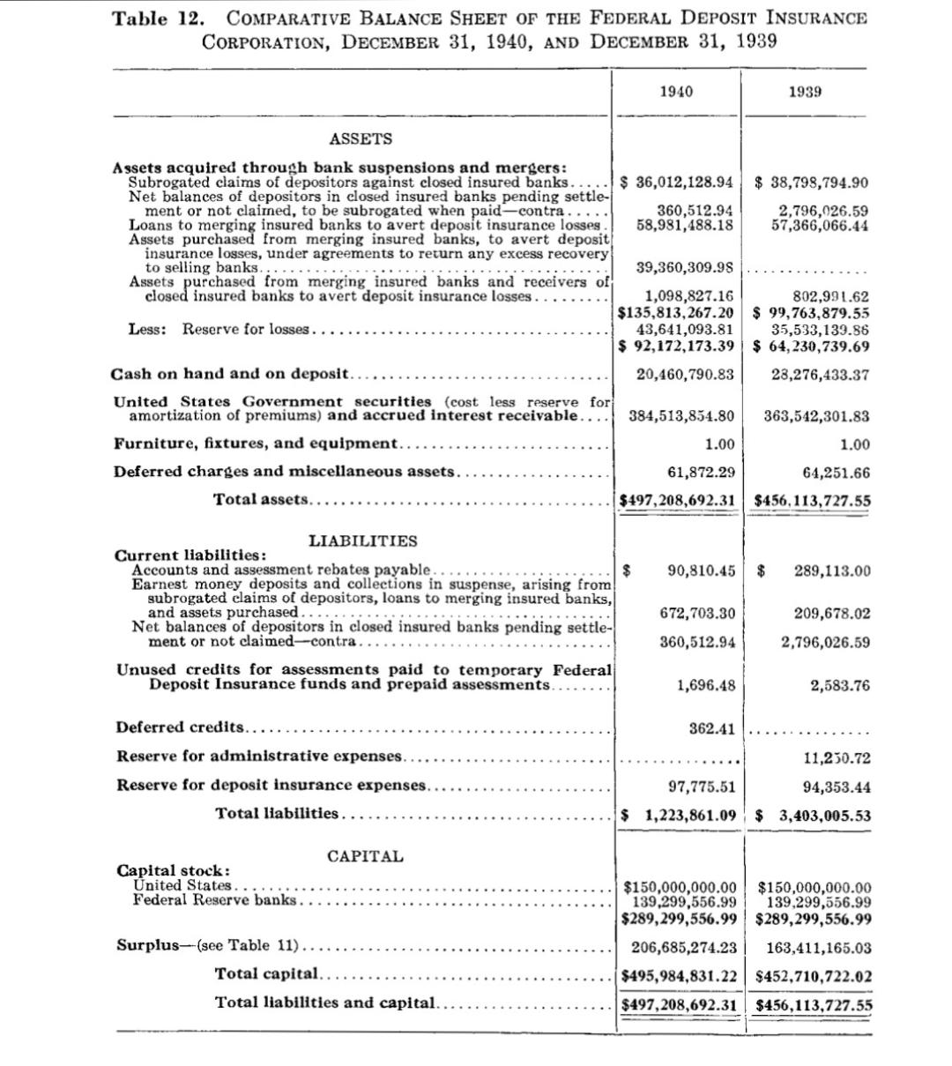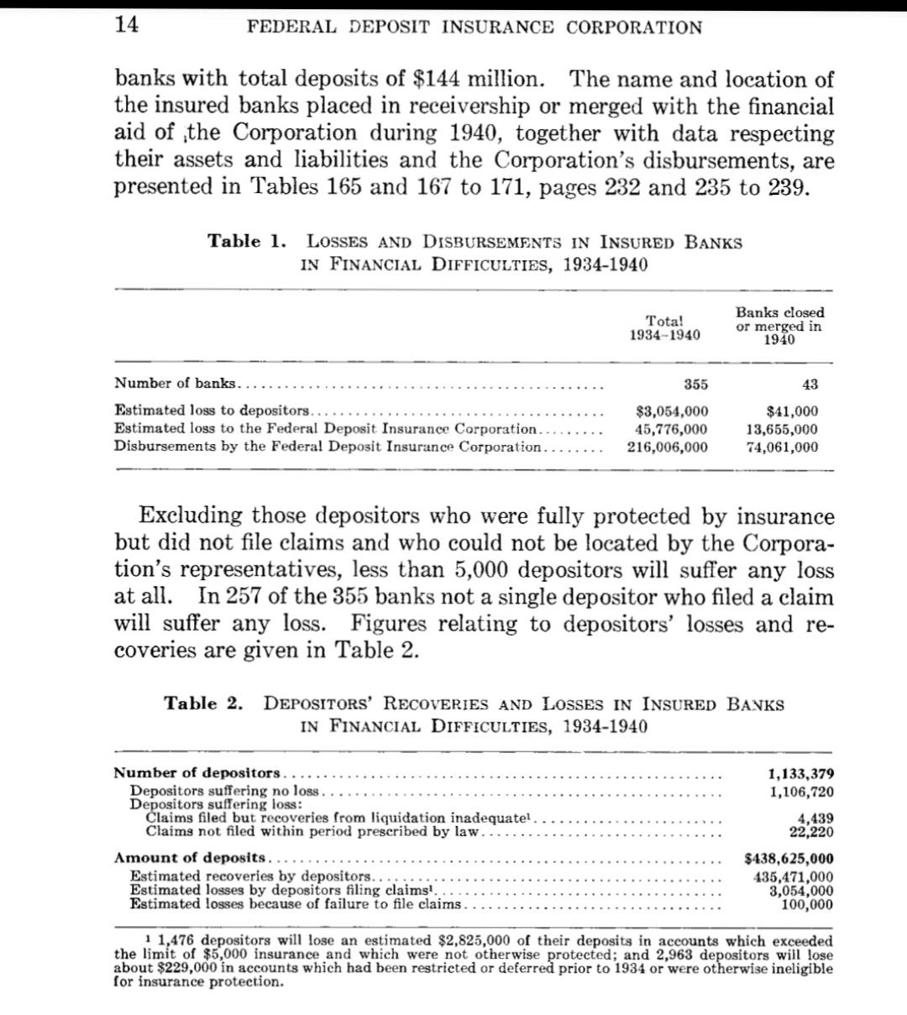

1. **Support for the War Economy**

Industrial Financing: Banks provided financing to support the expansion of wartime industries, such as manufacturing, defense production, and infrastructure development.

Workforce Support: Banks facilitated payroll services and financial support for workers employed in essential industries and military-related activities.

1. **War-Related Services**

Military Banking Services: Banks provided specialized banking services for military personnel, including overseas banking services, deployment allowances, and financial assistance for families of servicemembers.

Government Contracts: Banks managed financial transactions and provided banking services for government agencies involved in procurement, logistics, and military operations.

1. **Economic Recovery and Reconstruction**

Post-War Reconstruction Financing: Banks played a key role in financing post-war reconstruction efforts, including infrastructure development, housing projects, and economic recovery programs.

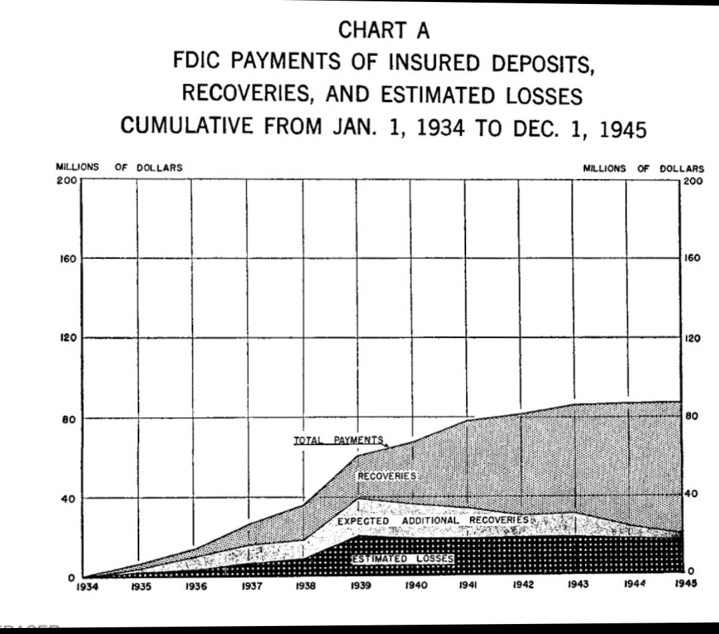Transition to Peacetime Economy: Banks supported the transition from a wartime to a peacetime economy by providing financing for demobilization, job training programs, and economic diversification.

**Time of end of the war**

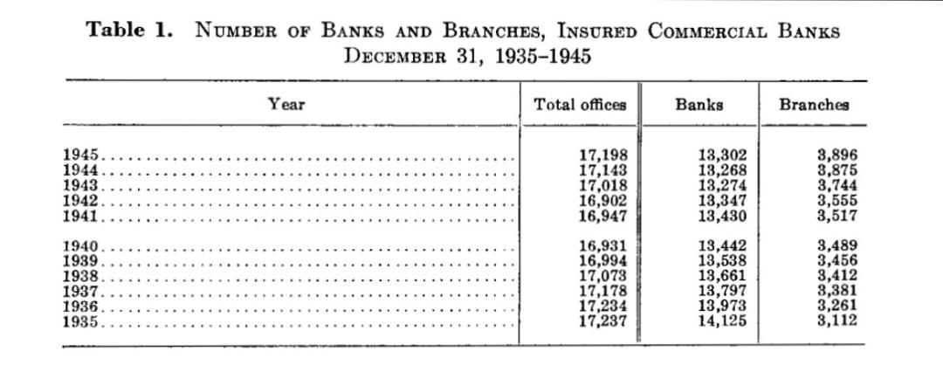

**campared of annual reports of us fdic between 1940 to 1945. Which year they performed well and how they manage at the time of war, their contribution to economy,**

Analyzing the FDIC annual reports from 1940 to 1945 can provide valuable insights into the banking sector’s performance during World War II and its broader contribution to the economy. By examining financial data, regulatory measures, economic impact, and the FDIC’s role in supporting the war effort, you can gain a comprehensive understanding of the challenges and opportunities faced by the banking system during this pivotal period in history.

During the COVID-19 pandemic, the U.S. banking system managed and survived through a combination of rapid response, regulatory adjustments, government support, and innovative approaches to serving customers. Here’s an overview of how the banking system managed during the pandemic:

1. **Rapid Adoption of Digital Banking**

Shift to Digital Channels: Banks quickly adapted to the increased demand for online and mobile banking services as customers avoided physical branches.

Remote Work Infrastructure: Banks invested in remote work infrastructure to ensure employees could work safely and effectively from home while maintaining operations.

1. **Regulatory Flexibility and Support**

Regulatory Relief: Regulators provided temporary relief and adjustments to regulations to support banks and facilitate lending. For example, regulatory agencies allowed flexibility in loan modifications and reporting requirements.

Capital and Liquidity Measures: Regulators encouraged banks to use their capital and liquidity buffers to support lending and absorb losses, ensuring financial stability.

1. **Economic Relief Programs**

Paycheck Protection Program (PPP): Banks played a critical role in administering PPP loans to small businesses, facilitating access to funds to retain employees and cover essential expenses.

Stimulus Payments: Banks assisted in distributing stimulus payments to individuals, ensuring timely access to financial relief.

1. **Enhanced Customer Support**

Loan Forbearance and Assistance: Banks offered loan forbearance programs and assistance to customers facing financial hardship, such as deferring mortgage payments or waiving fees.

Increased Communication: Banks communicated proactively with customers, providing information on relief options, branch operations, and safety measures.

1. **Financial Stability Measures**

Federal Reserve Interventions: The Federal Reserve implemented monetary policy measures, including interest rate cuts and liquidity injections, to stabilize financial markets and ensure liquidity in the banking system.

Stress Testing and Risk Management: Banks conducted stress tests and risk assessments to evaluate their resilience to economic shocks and adjust their strategies accordingly.

1. **Community Support and Engagement**

Community Outreach: Banks engaged in community support initiatives, such as donations to local organizations, to assist communities affected by the pandemic.

Support for Small Businesses: Banks provided guidance and financial support to small businesses navigating government relief programs and accessing capital.

1. **Focus on Health and Safety**

Safety Protocols: Banks implemented safety protocols in branches, such as social distancing measures, enhanced cleaning procedures, and the use of protective equipment, to ensure the safety of customers and employees.

Employee Support: Banks prioritized the health and well-being of their employees, offering support services and flexibility to accommodate individual needs during the pandemic.

1. **Technological Innovation**

Fintech Collaboration: Banks collaborated with fintech companies to enhance digital capabilities and offer innovative financial solutions, such as contactless payments and digital lending platforms.

Automation and Efficiency: Banks invested in automation and digitization to improve efficiency and streamline processes, enabling faster service delivery and response times.

**Summary of Key Policies**

Liquidity Provision: Central banks provided liquidity to prevent bank runs and ensure financial stability (e.g., Federal Reserve discount window, quantitative easing).

Deposit Insurance: The establishment of the FDIC provided deposit insurance to restore public confidence.

Regulatory Reforms: Major legislative reforms like the Glass-Steagall Act, FIRREA, and Dodd-Frank Act increased oversight, reduced systemic risks, and enhanced consumer protection.

Stress Testing and Capital Requirements: Post-2008, regular stress testing and higher capital requirements were implemented to ensure banks could withstand economic shocks.

Government Bailouts and Asset Purchases: Programs like TARP during the 2008 crisis and PPP during the COVID-19 pandemic provided direct financial support to stabilize the banking system and the economy.

Contribution to the Country

During economic crises, the U.S. banking system’s primary contributions have been

Stabilizing the Economy: Providing liquidity and preventing bank runs.

Supporting Businesses and Individuals: Facilitating credit and financial services to maintain economic activity.

Implementing Monetary Policy: Managing interest rates and financial conditions to promote economic recovery.

Enhancing Financial Stability: Introducing reforms and oversight to reduce risks and prevent future crises.

Through these measures, the U.S. banking system has played a vital role in mitigating the impacts of economic crises and supporting the country’s economic resilience and recovery